Attachment A - Locality Map
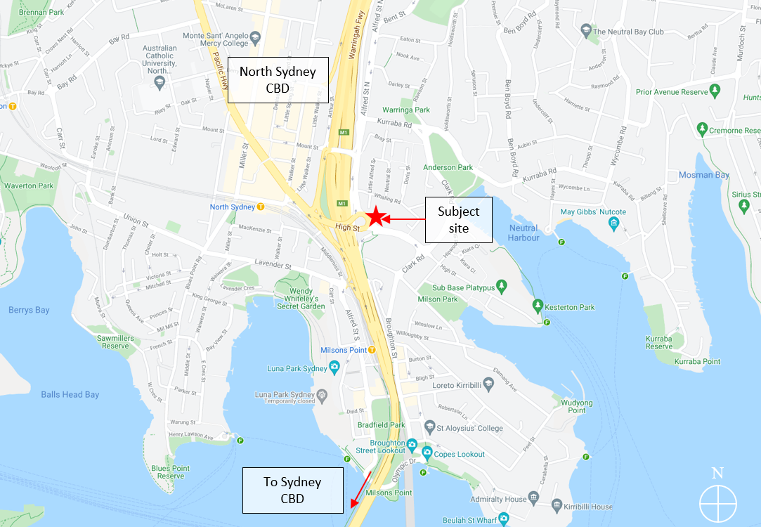
Site
Chatswood CBD Strategy
Figure 1: Locality (source: Nearmap, overlay by DPIE)

